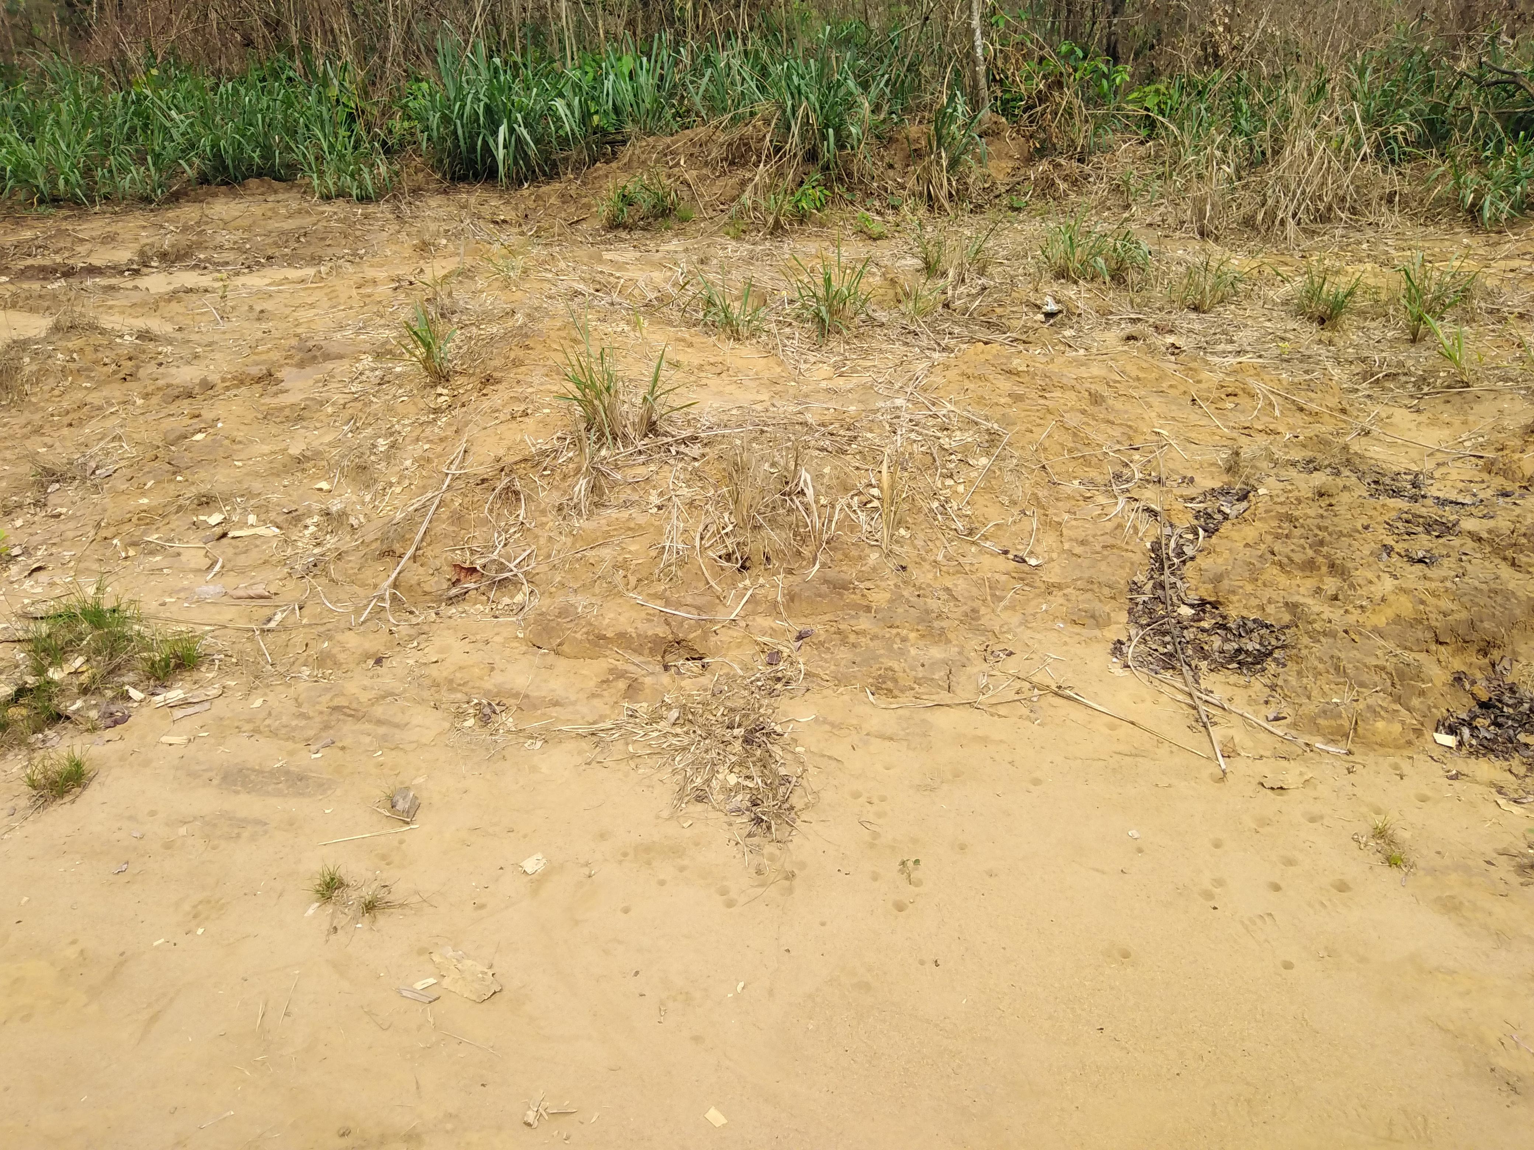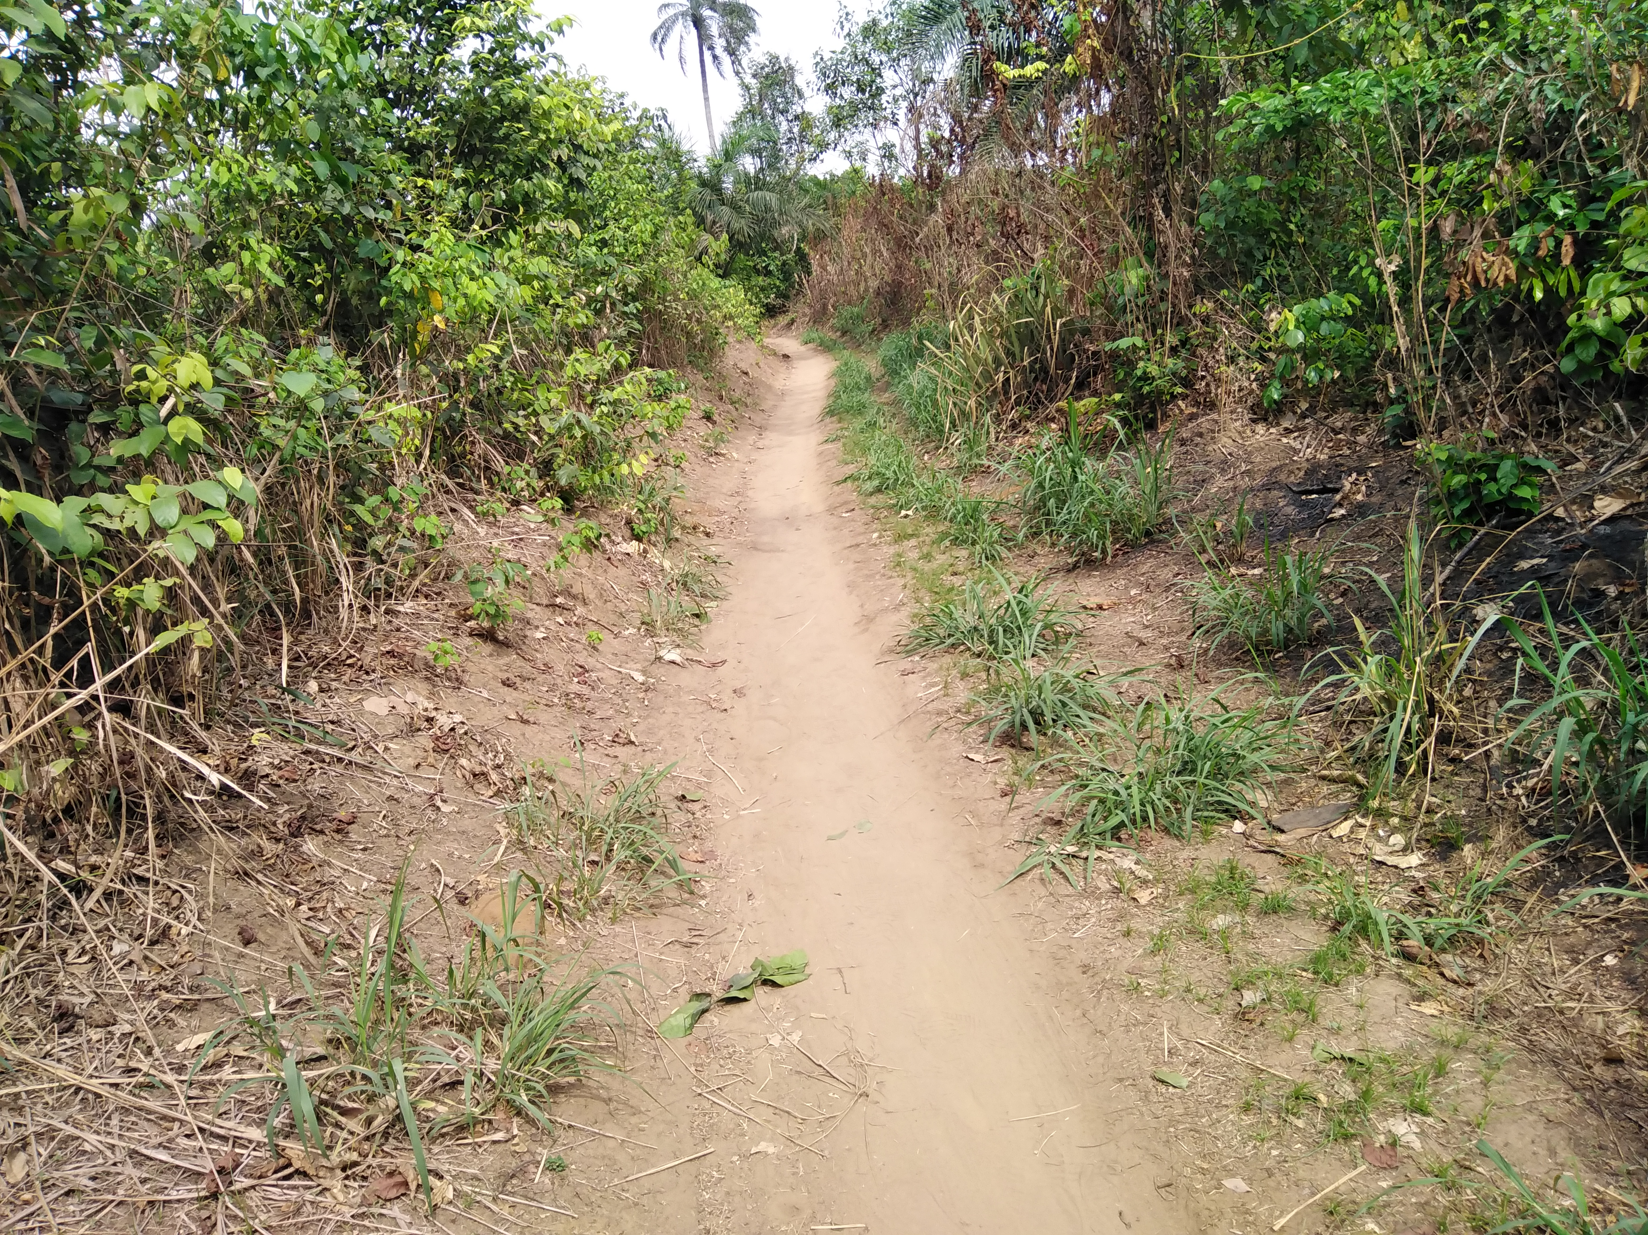
Spill Point where samples were taken Spill Area
Certification Pictures; Regeneration seen, grasses and plants growing

